MS SQL Server 2022 & SSMS

Installation in Windows 10/11

Step 1: Download and install MS Visual Studio 2022 Community Edition
https://visualstudio.microsoft.com/vs/community/

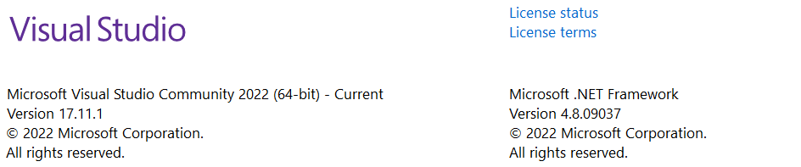

Step 2: Download and install SQL Server 20.2 and SSMS 20.2
YouTube Video for installation:
https://youtu.be/Tbru4JJdYYk?si=CZoO2STkOcrskNaG

URL for SSMS 2022:
https://learn.microsoft.com/en-us/sql/ssms/download-sql-server-management-studio-ssms?view=sql-server-ver16

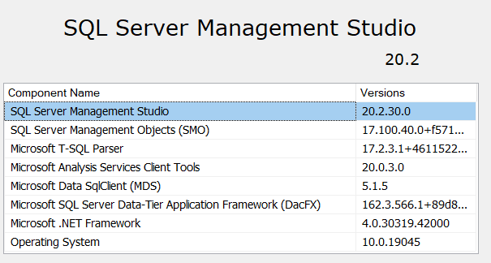

Step 3:
Verify the SQL Server connection parameters. It should look like the one shown below:
Note that the Login and password must be "sa" and " " (whatever you have given at the time of installation.)
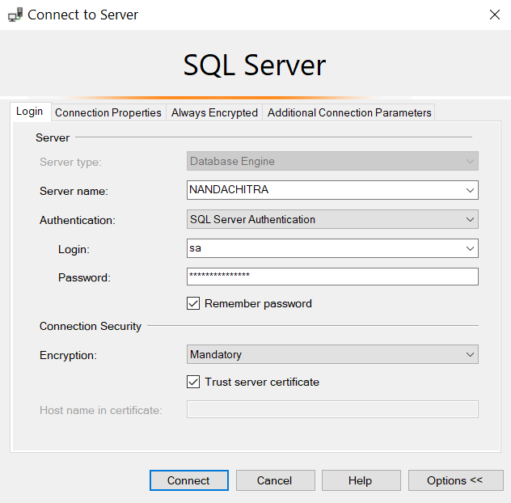

Similarly, you can connect to Analysis Service also.

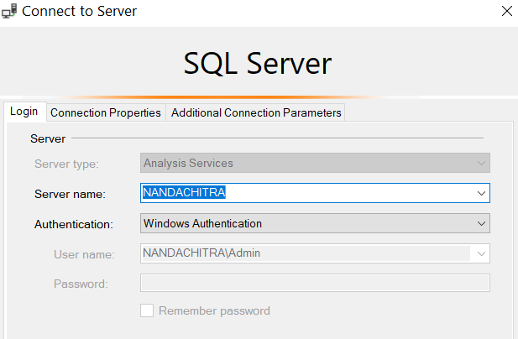

For this Windows Authentication is used.

Building a Multidimensional Database "Sales"

Problem 1: Create a Multidimensional Database called "Sales" with Dimensional Tables: Customer, Product, and Location. Also create a Fact table called "MFUOrder".

Solution:

Step 1: Right Click Databases and create a new database "Sales"

Step 2: Create the three dimensional tables as mentioned in the problem statement (Right click on Tables and create new table.) The Design structure is given below:

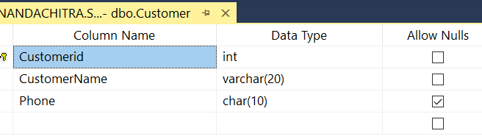

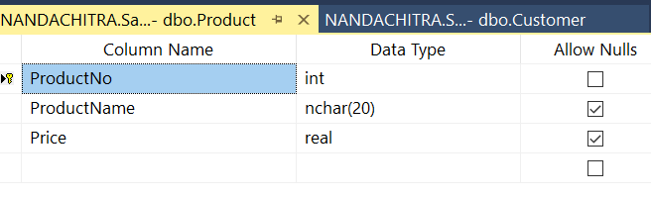

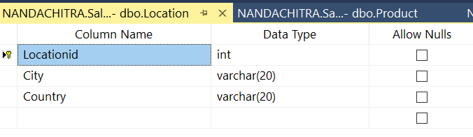

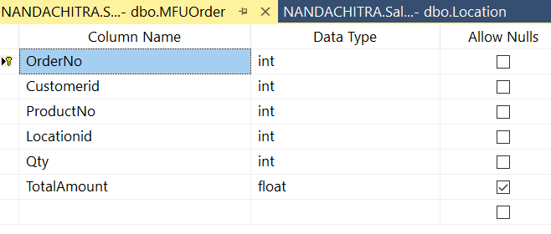

Note that Customerid, ProductNo, and Locationid are Foreign keys.
Alternatively, the following SQL code can be executed by clicking "New Query" button:

CREATE TABLE [Sales].[dbo].[Customer](
[Customerid] [int] NOT NULL,
[CustomerName] [varchar](20) NOT NULL,
[Phone] [char](10) NULL,
CONSTRAINT [PK_Customer] PRIMARY KEY CLUSTERED
(
[Customerid] ASC
)WITH (PAD_INDEX = OFF, STATISTICS_NORECOMPUTE = OFF, IGNORE_DUP_KEY = OFF, ALLOW_ROW_LOCKS = ON, ALLOW_PAGE_LOCKS = ON, OPTIMIZE_FOR_SEQUENTIAL_KEY = OFF) ON [PRIMARY]
) ON [PRIMARY]

CREATE TABLE [Sales].[dbo].[Location](
[Locationid] [int] NOT NULL,
[City] [varchar](20) NOT NULL,
[Country] [varchar](20) NOT NULL,
CONSTRAINT [PK_Location] PRIMARY KEY CLUSTERED
(
[Locationid] ASC
)WITH (PAD_INDEX = OFF, STATISTICS_NORECOMPUTE = OFF, IGNORE_DUP_KEY = OFF, ALLOW_ROW_LOCKS = ON, ALLOW_PAGE_LOCKS = ON, OPTIMIZE_FOR_SEQUENTIAL_KEY = OFF) ON [PRIMARY]
) ON [PRIMARY]

CREATE TABLE [Sales].[dbo].[Product](
[ProductNo] [int] NOT NULL,
[ProductName] [nchar](20) NULL,
[Price] [real] NULL,
CONSTRAINT [PK_Product] PRIMARY KEY CLUSTERED
(
[ProductNo] ASC
)WITH (PAD_INDEX = OFF, STATISTICS_NORECOMPUTE = OFF, IGNORE_DUP_KEY = OFF, ALLOW_ROW_LOCKS = ON, ALLOW_PAGE_LOCKS = ON, OPTIMIZE_FOR_SEQUENTIAL_KEY = OFF) ON [PRIMARY]
) ON [PRIMARY]

CREATE TABLE [Sales].[dbo].[MFUOrder](
[OrderNo] [int] NOT NULL,
[Customerid] [int] NOT NULL,
[ProductNo] [int] NOT NULL,
[Locationid] [int] NOT NULL,
[Qty] [int] NOT NULL,
[TotalAmount] [float] NULL,
CONSTRAINT [PK_Order] PRIMARY KEY CLUSTERED
(
[OrderNo] ASC
)WITH (PAD_INDEX = OFF, STATISTICS_NORECOMPUTE = OFF, IGNORE_DUP_KEY = OFF, ALLOW_ROW_LOCKS = ON, ALLOW_PAGE_LOCKS = ON, OPTIMIZE_FOR_SEQUENTIAL_KEY = OFF) ON [PRIMARY]
) ON [PRIMARY]

Step 2:
Insert data to all the tables by executing the following SQL statements:

INSERT INTO SALES.DBO.CUSTOMER VALUES(111,'KEMIKA',7004080001);
INSERT INTO SALES.DBO.CUSTOMER VALUES(222,'PHAKORN',9000086456);
INSERT INTO SALES.DBO.CUSTOMER VALUES(333,'ALLEN',6554080002);
INSERT INTO SALES.DBO.CUSTOMER VALUES(444,'SOWMYA',9954080003);
INSERT INTO SALES.DBO.CUSTOMER VALUES(555,'SORAVIT',6654080034);

INSERT INTO SALES.DBO.PRODUCT VALUES(55,'LAPTOP',34345.102);
INSERT INTO SALES.DBO.PRODUCT VALUES(66,'WATCH',200.5);
INSERT INTO SALES.DBO.PRODUCT VALUES(77,'SHIRT',145);
INSERT INTO SALES.DBO.PRODUCT VALUES(88,'MOBILE',1345.99);
INSERT INTO SALES.DBO.PRODUCT VALUES(99,'SHOE',345.98999);

INSERT INTO SALES.DBO.LOCATION VALUES(1,'NEW YORK','USA');
INSERT INTO SALES.DBO.LOCATION VALUES(5,'BANGKOK','THAILAND');
INSERT INTO SALES.DBO.LOCATION VALUES(9,'BANGALORE','INDIA');

INSERT INTO SALES.DBO.MFUORDER VALUES(1000,111,77,5,3,0);
INSERT INTO SALES.DBO.MFUORDER VALUES(2000,111,55,5,13,0);
INSERT INTO SALES.DBO.MFUORDER VALUES(3000,222,88,1,2,0);
INSERT INTO SALES.DBO.MFUORDER VALUES(4000,333,66,1,8,0);
INSERT INTO SALES.DBO.MFUORDER VALUES(5000,333,77,5,10,0);
INSERT INTO SALES.DBO.MFUORDER VALUES(6000,111,77,5,3,0);
INSERT INTO SALES.DBO.MFUORDER VALUES(7000,111,77,5,3,0);
Step 3: Finally, update the "TotalAmount" column of MFUOrder using the below code:
UPDATE SALES.DBO.MFUORDER SET TOTALAMOUNT=QTY*(
SELECT SALES.DBO.Product.Price
FROM SALES.DBO.Product
WHERE SALES.DBO.MFUORDER.ProductNo=SALES.DBO.Product.ProductNo);

Building a Cube in VS Studio 2022

Step 1: In VS Studio 2022, click Create New Project→Analysis Services Multidimensional Project→Next.

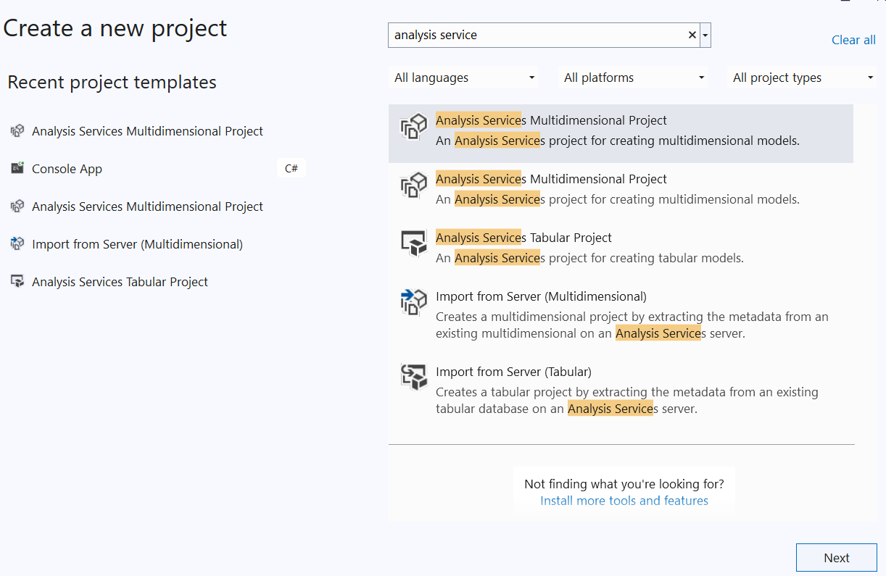

Step 2: Type the Project Name→Create. We are using the Project Name as "Multi4".
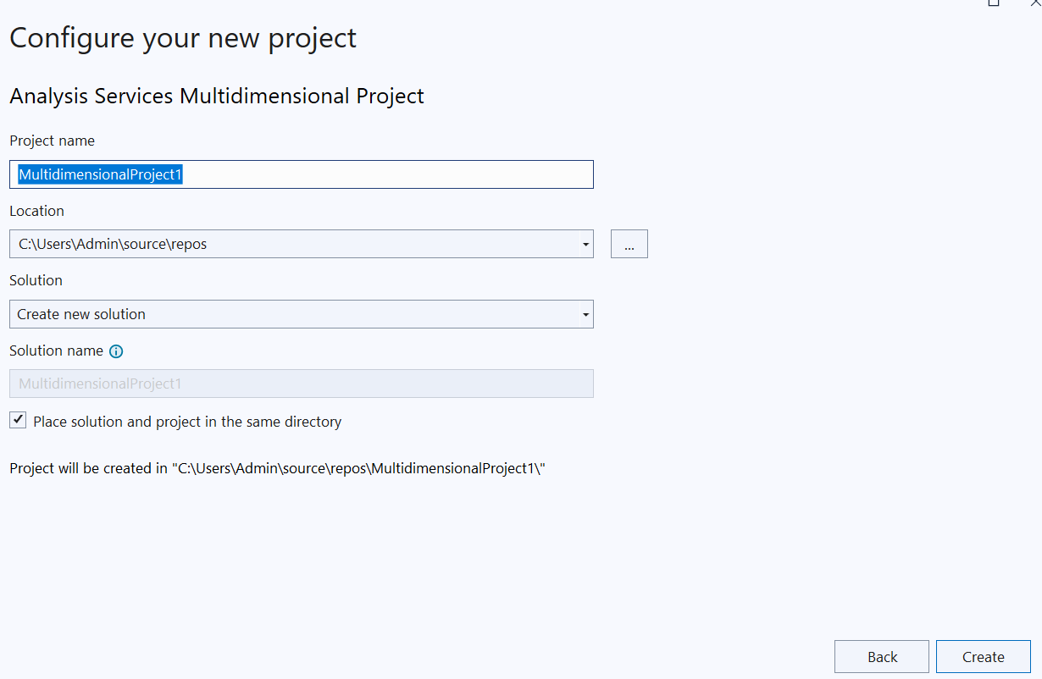
Step 3: In the Solution Explorer Right click Data Sources→ New Data Source. The Data Source Wizard should be like this:
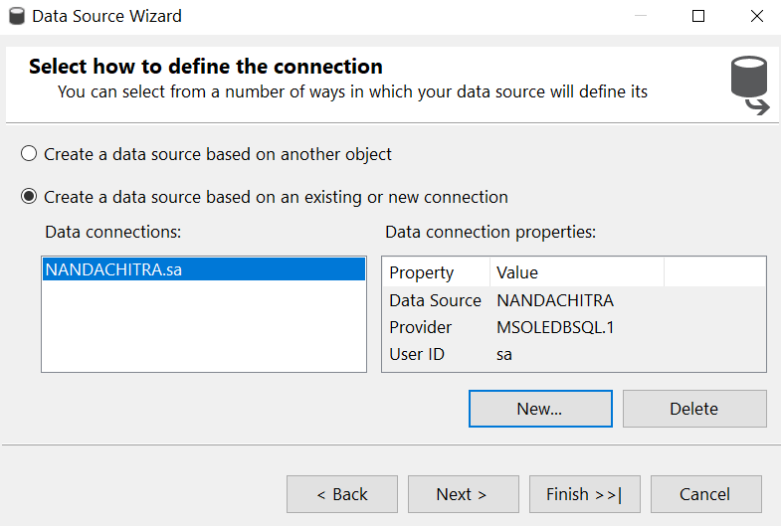

Step 4: Click New button. Enter the details as shown below:
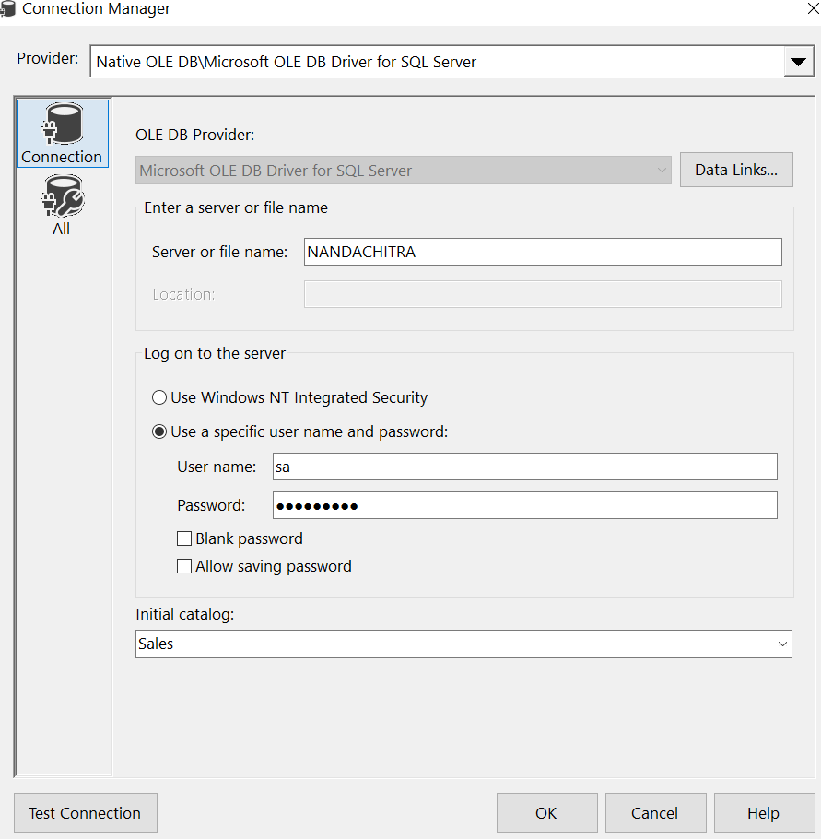

Make sure that the impersonation window is selected with "Use the Service Account".
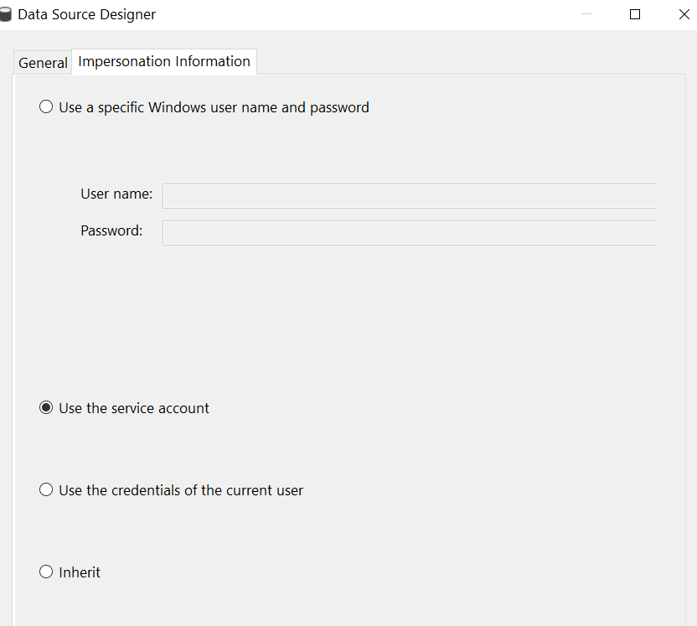

Step 5: Click OK and Data Source Wizard, you can give any name for the object.

Step 6: Right Click Data Source Views → New Data Source View
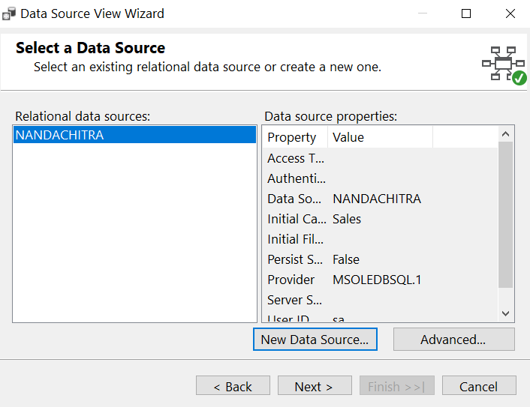

Step 7: In this Wizard, select all tables → Next:
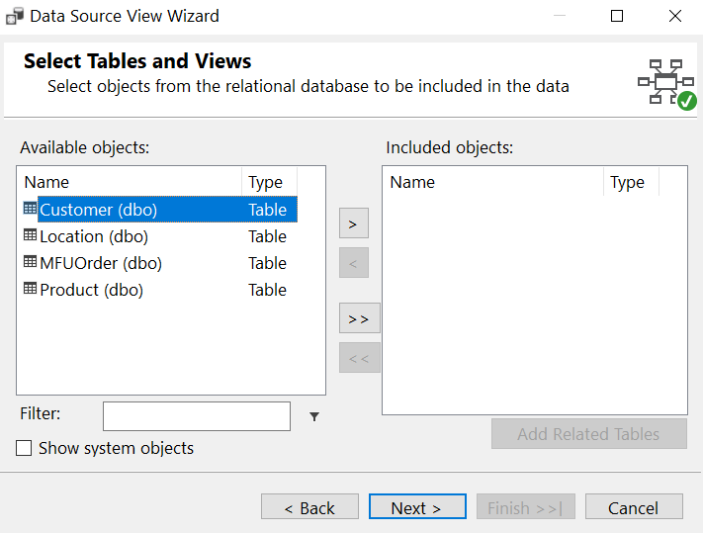

Step 8: Give name as MFUSalesView.

Step 9: Right Click Cubes → New Cube → Next
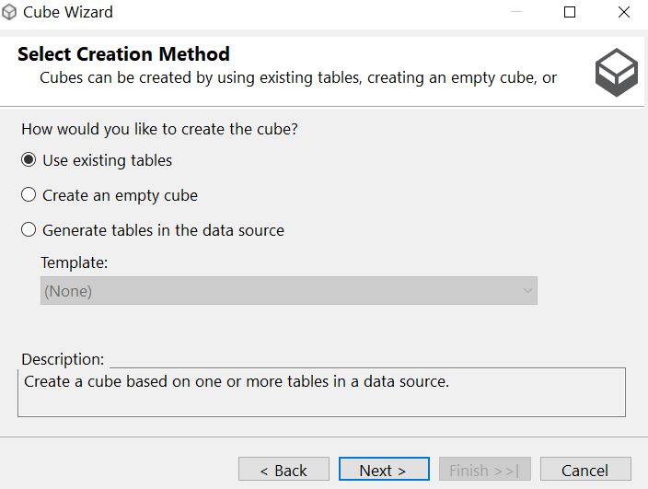

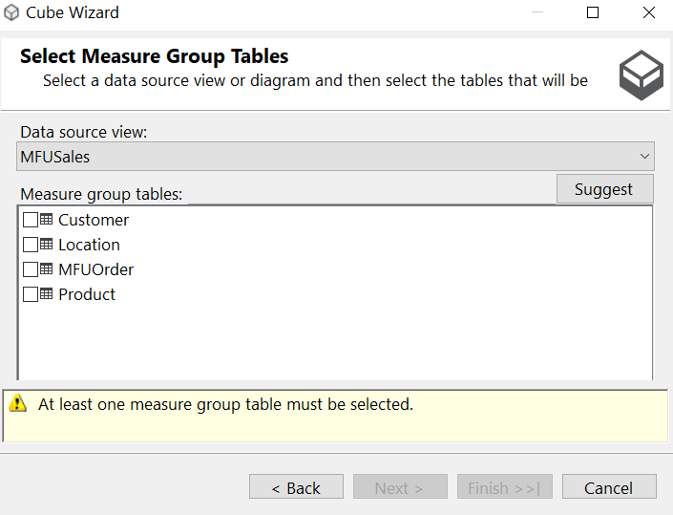
Check box MFUOrder should be selected. Then keep clicking Next and give the name as MFUSalesCube and click Finish.

Step 10: Right Click MFUSalesCube and select Process. The cube will be processed and deployed.
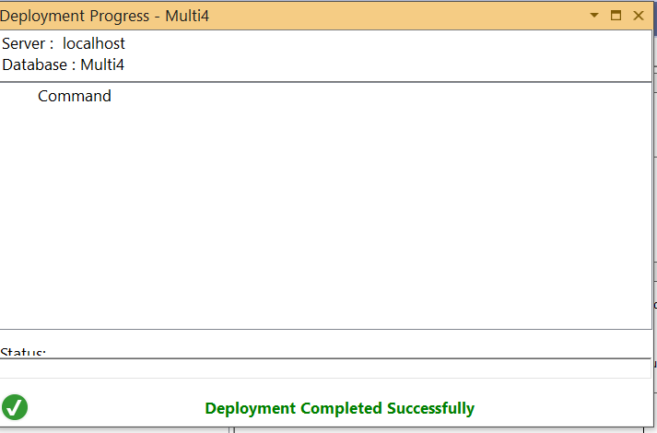

In the next window click Run (if you don't see Run button go to full window mode.)
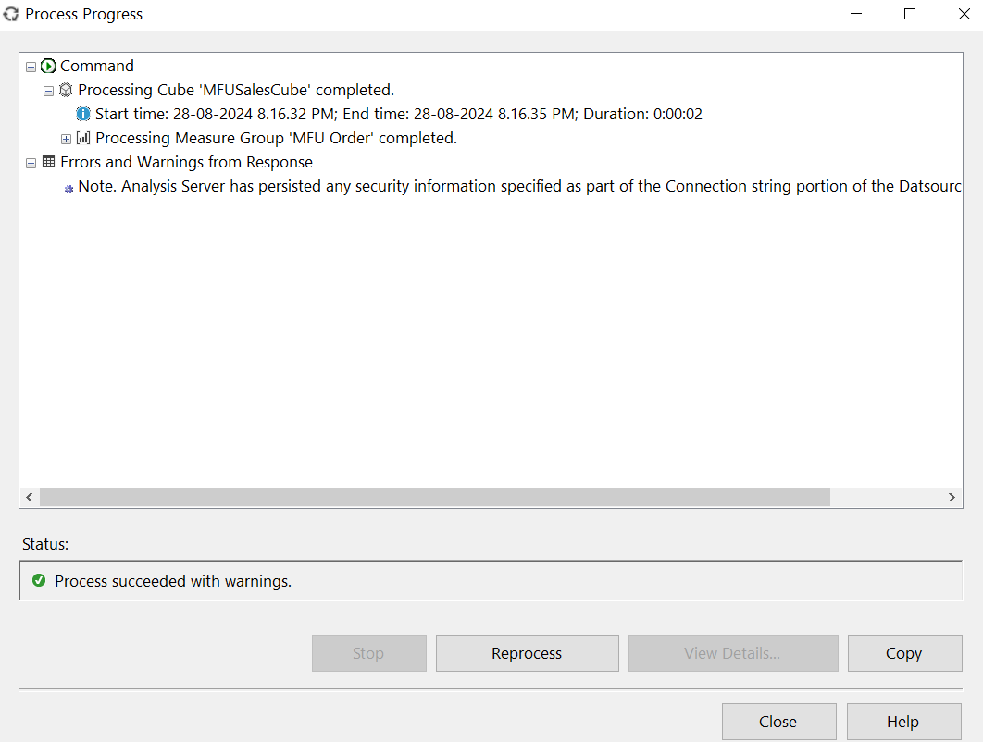

If you see this window it means that everything is ok.

Step 11: In the cube tab, click Browser button.

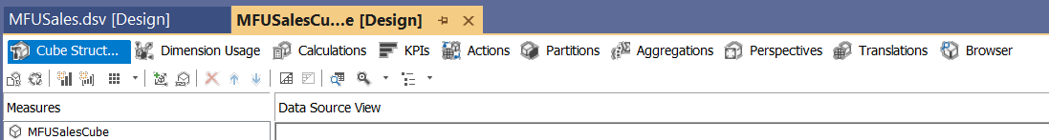

Step 12: From left pane, expand Measures→MFUOrder and drag MFU Order Count, Qty, and Total Amount. Click to Execute the Query.
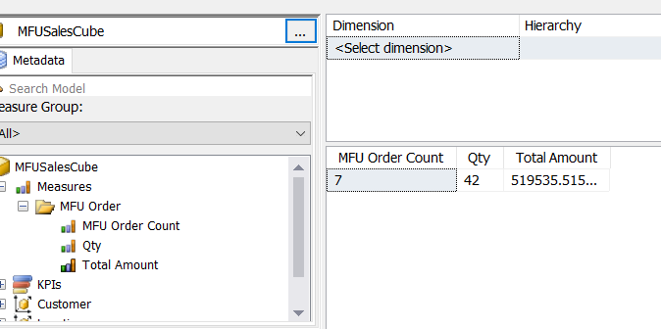

You can bring the dimension table attributes also to get the OLAP operations executed. For example, location based OLAP data can be obtained, after dragging the Locationid from Location Dimension table:

